Common infrared LED that emits infrared rays has the same appearance with visible light LED. Its appropriate operating voltage is around 1.4v and the current is generally smaller than 20mA. Current limiting resistances are usually connected in series in the infrared LED circuits to adjust the voltages, helping the LEDs to be adapted to different operating voltages.

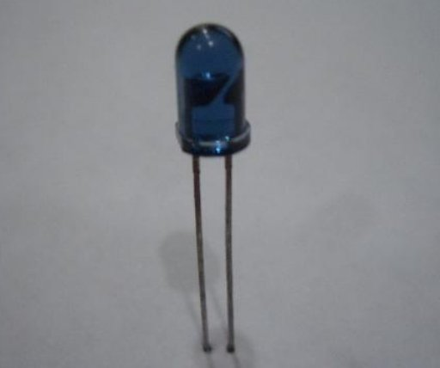

When using infrared rays to control correspondent unit, the controlling distance is in direct ratio with the emitting power. In order to lengthen its controlling distance, infrared LED should be operated under pulse state as the effective transmitting distance of the pulsed light (modulated light) is in proportion with the wind-induced current of the pulses. Thus, by increasing the peak value (Ip) of the pulses, the emitting distance of the infrared LED can also be lengthened. One way to increase Ip is to diminish the duty ratio of the pulse; that is to reduce the width of the pulse (T). The duty ratios of the working pulses for some color TV’s infrared remote controllers are around 1/3-1/4; and for some other electronic products, the duty ratios of the infrared remote controllers can even be as small as 1/10. Through reducing the duty ratio of the pulses, the emitting distance for small power infrared LED can also be increased in a large extent. Ordinary infrared LEDs can be divided into the following three types: small power one (1mW-10mW), medium power LED (10mW-50mW) and large power LED (50mW-100mW and above). The modulated light can be generated by adding pulse voltage with specific frequency on the driving diode.

The controller with infrared LED can emit infrared rays to take control of correspondent unit, and at the controlled unit end, there is also a receiving device to turn the infrared light into electricity, such as infrared light receiving diode, photoelectric triode and so on. Emitting and receiving matched infrared diode has also been applied in practical use.

There are two emitting-receiving modes for infrared LED and the controlled unit, one is direct light emitting mode, and the other is reflecting light mode. In the direct light emitting mode, the emitting diode and the receiving diode are installed in the emitting end and the controlled unit end respectively, with a certain distance between them. As to the reflecting light mode, the lighting diode and the receiving diode are in parallel. Only when the infrared rays emitted by the diode were reflected by something can the receiving diode get the infrared rays, thereby stimulate the controlled unit to operate. Besides, infrared emitting circuit with double diodes bears higher power and longer functional distance.

Infrared LED chips with different wavelengths can be applied in extensive devices, for example:

1. Infrared LED chip with wavelength of 940nm: suitable to be used in remote controller, such as remote controllers for household appliances.

2. 808nm: suitable to be used in medical treatment appliances, space optical communication, infrared illumination and the pumping sources of the solid-state lasers.

3. 830nm: suitable to be used in the automated card reader system in freeway.

4. 840nm: suitable to be used in colored zoom infrared waterproof video camera.

5. 850nm: suitable to be used in video cameras that are applied in digital photography, monitoring system, door phone, theftproof alarm and so on.

1. 870nm: suitable to be used in video cameras in marketplace and crossroad

**Photodiode**

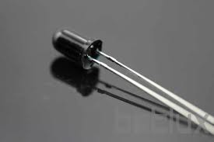

A photodiode is a type of photodetector capable of converting light

into either current or voltage, depending upon the mode of

operation.

Photodiodes are similar to regular semiconductor diodes except that

they may be either exposed (to detect vacuum UV or X;rays) or

packaged with a window or optical fibre connection to allow light to

reach the sensitive part of the device. Many diodes designed for use

specifically as a photodiode will also use a PIN junction rather than

the typical PN junction.

**Polarity**

Some photodiodes will look like the picture to the right, that is, similar to a light emitting diode.

They will have two leads, or wires, coming from the bottom. The shorter end of the two is the

cathode, while the longer end is the anode. See below for a schematic drawing of the anode and

cathode side. Under forward bias, conventional current will pass from the anode to the cathode,

following the arrow in the symbol. Photocurrent flows in the opposite direction.

**Principle of operation**

A photodiode is a PN junction or PIN structure. When a photon of sufficient energy strikes the

diode, it excites an electron, thereby creating a mobile electron and a positively charged electron

hole. If the absorption occurs in the junction's depletion region, or one diffusion length away from

it, these carriers are swept from the junction by the built;in field of the depletion region. Thus

holes move toward the anode, and electrons toward the cathode, and a

photocurrent is produced.

**Photovoltaic mode**

When used in zero bias or photovoltaic mode, the flow of photocurrent

out of the device is restricted and a voltage builds up. The diode

becomes forward biased and "dark current" begins to flow across the

junction in the direction opposite to the photocurrent. This mode is

responsible for the photovoltaic effect, which is the basis for solar

cells—in fact, a solar cell is just an array of large area photodiodes.

**Photoconductive mode**

In this mode the diode is often (but not always) reverse biased. This increases the width of the depletion layer, which

decreases the junction's capacitance resulting in faster response times. The reverse bias induces only a small amount

of current (known as saturation or back current) along its direction while the photocurrent remains virtually the same.

The photocurrent is linearly proportional to the illuminance.

**Features**

Critical performance parameters of a photodiode include:

**responsivity**

The ratio of generated photocurrent to incident light power, typically expressed in A/W when used in

photoconductive mode. The responsivity may also be expressed as a quantum efficiency, or the ratio of the number of photogenerated carriers to incident photons and thus a unitless quantity.

**dark current**

The current through the photodiode in the absence of light, when it is operated in photoconductive mode. The

dark current includes photocurrent generated by background radiation and the saturation current of the

semiconductor junction. Dark current must be accounted for by calibration if a photodiode is used to make an

accurate optical power measurement, and it is also a source of noise when a photodiode is used in an optical

communication system.